


AWS Solution Architect Training with AWS Cloud Practitioner Global Certification
Capstone Projects

Trainer: Aravindraj.G- Nminds Academy
AWS Academy Certified Educator




Configure VPC with Multiple Public & private Subnet

Public Subnet
Public Subnet

Private subnet
Private subnet

NAT gateway

GOKUL S

Objective
A VPC (Virtual Private Cloud) in Amazon Web Services (AWS) is a logically isolated virtual network inside AWS where you can launch and manage your cloud resources securely.
- Amazon Virtual Private Cloud (VPC) is a service that lets you launch AWS resources in a logically isolated virtual network that you define.
- It is logically isolated from other virtual networks in the AWS Cloud.
- A virtual private cloud (VPC) is a secure, isolated private cloud hosted within a public cloud.
- Amazon Virtual Private Cloud (Amazon VPC) hides the complexity, and simplifies the deployment of secure private networks.
Subnets:
A subnet is a sub range of IP addresses in the VPC. AWS resources can be launched into a specified subnet.
- After creating a VPC, you can add one or more subnets in each Availability Zone.


Private subnet
Public Subnet

- The public subnet resources that must be connected to the internet.
- The private subnet resources that must remain isolated from the internet.

Internet Gateway:

An internet gateway is a VPC component that allows communication between resources in your VPC and the internet. It is horizontally scaled, redundant, and highly available. An internet gateway supports IPv4 and IPv6 traffic. An internet gateway serves two purposes. First, it provides a target in your VPC route tables for internet-routable traffic. Second, the internet gateway performs network address translation (NAT) for instances that were assigned public IPv4 addresses.
Internet gateway

Topology
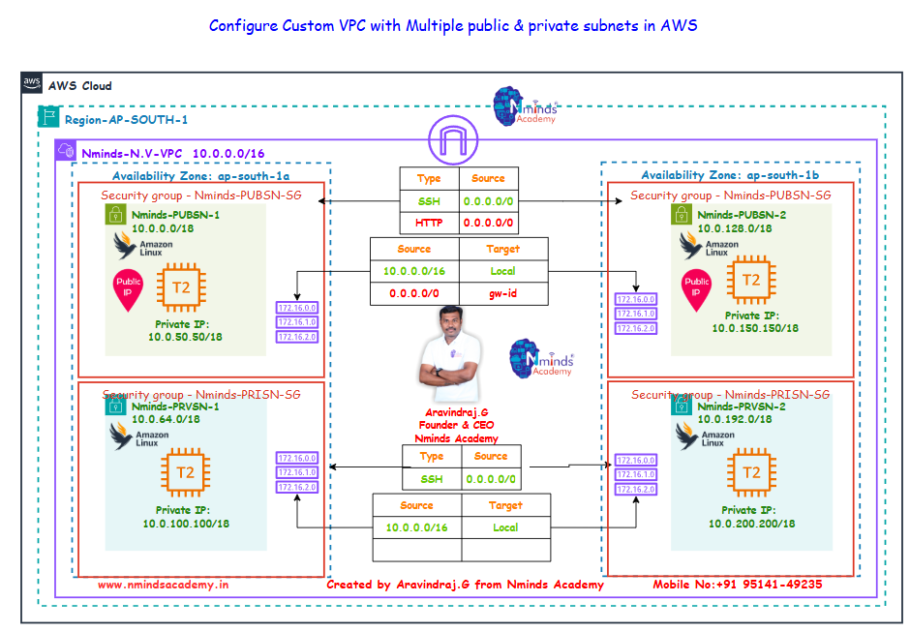


Used Services in AWS Used Services in Windows Server
Apache Webserver

Amazon VPC

Public subnet

Private subnet

Internet gateway


NAT gateway

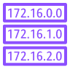
Route table


Amazon Elastic Compute Cloud (Amazon EC2)

Execution Steps:

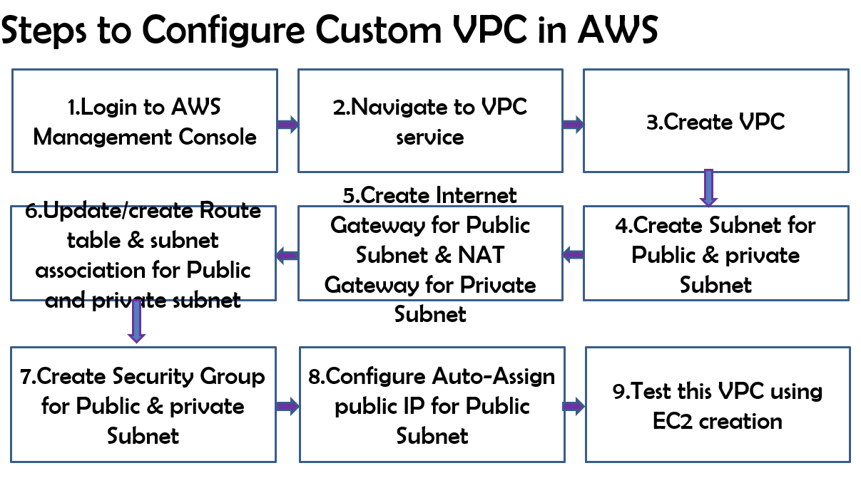

Execution Tasks:
Task1: Create the custom VPC with Public Subnet & private subnet based on the above topology:

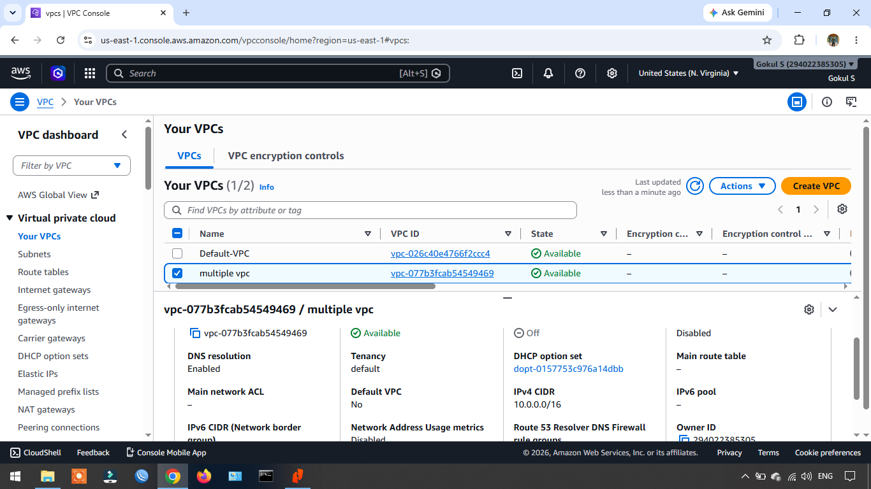
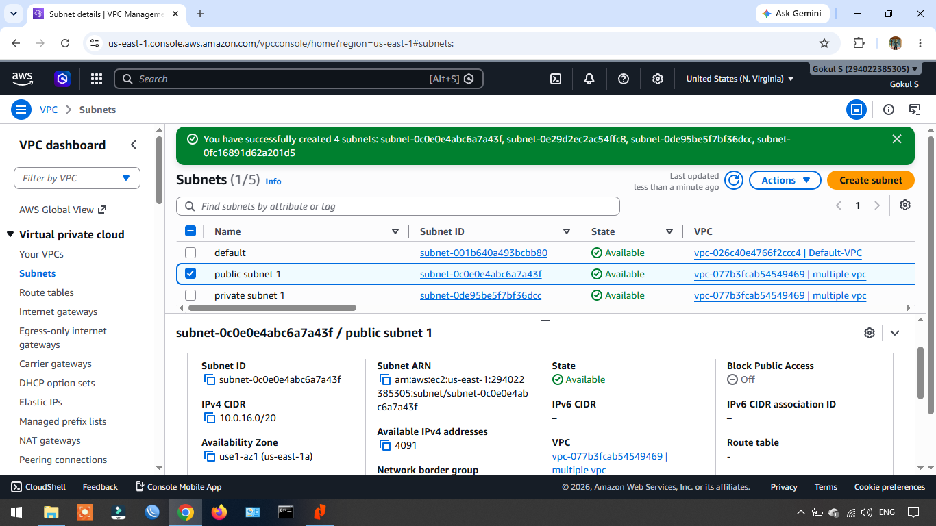

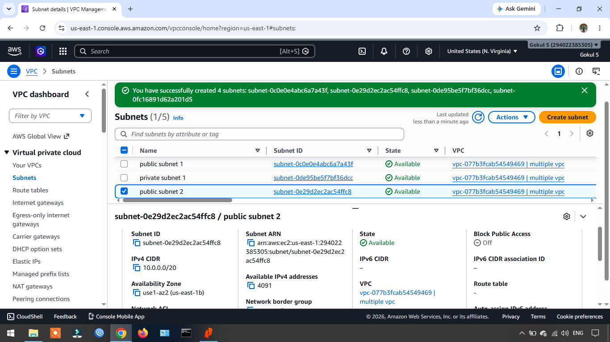

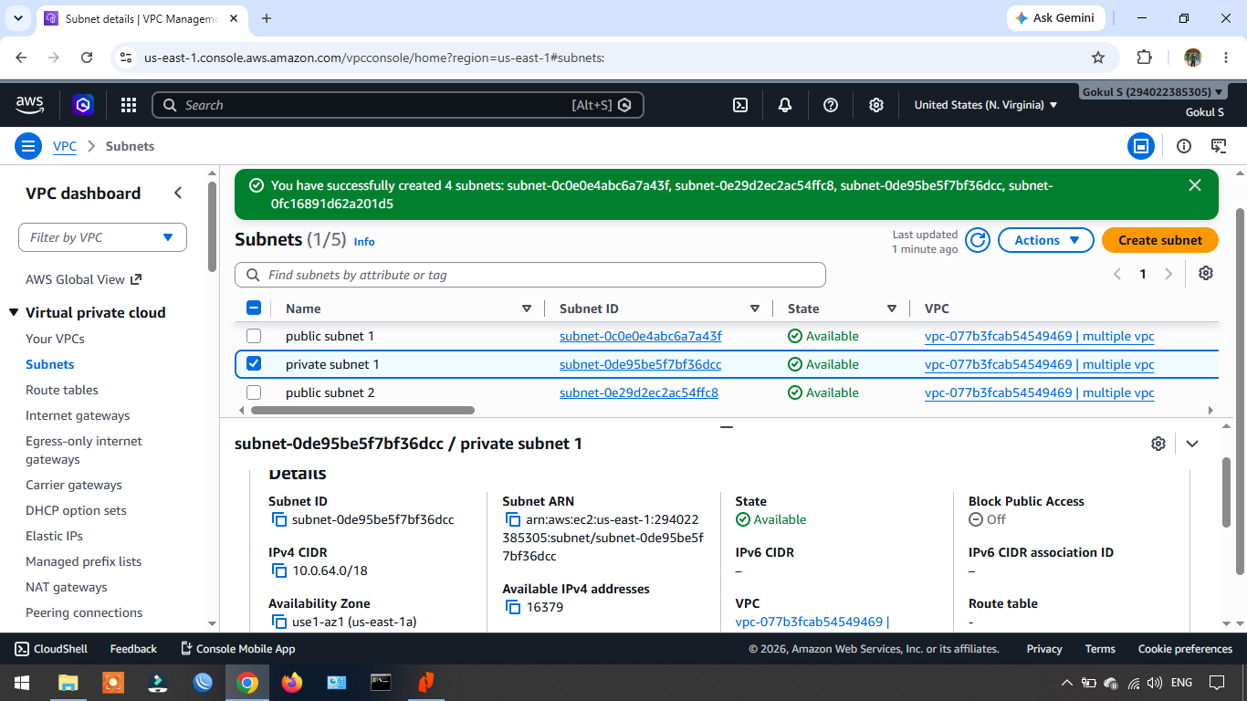

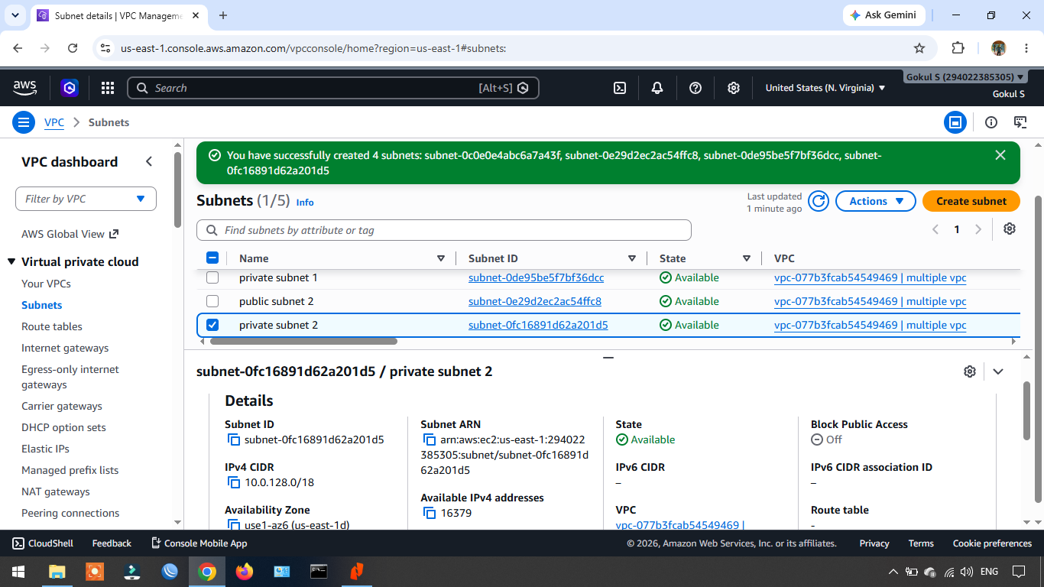

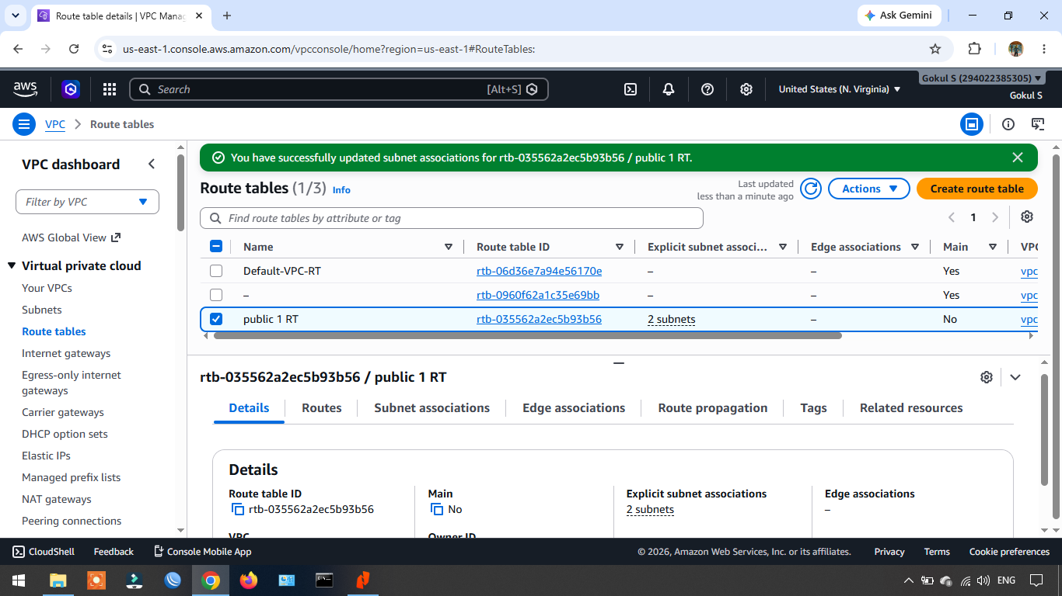

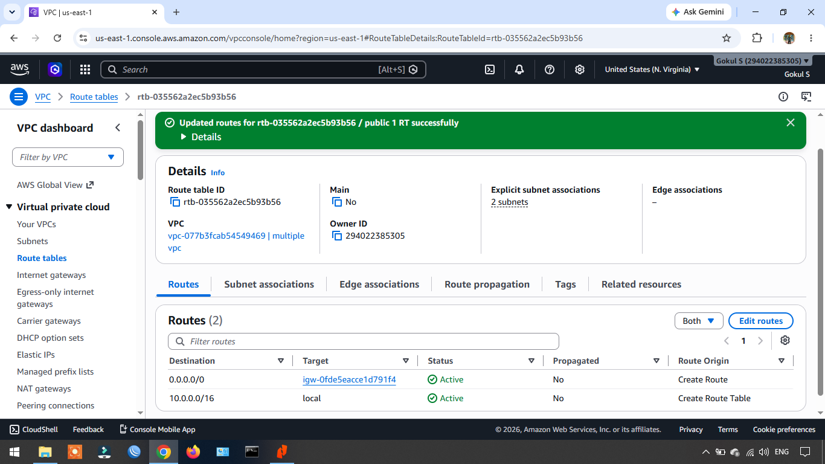

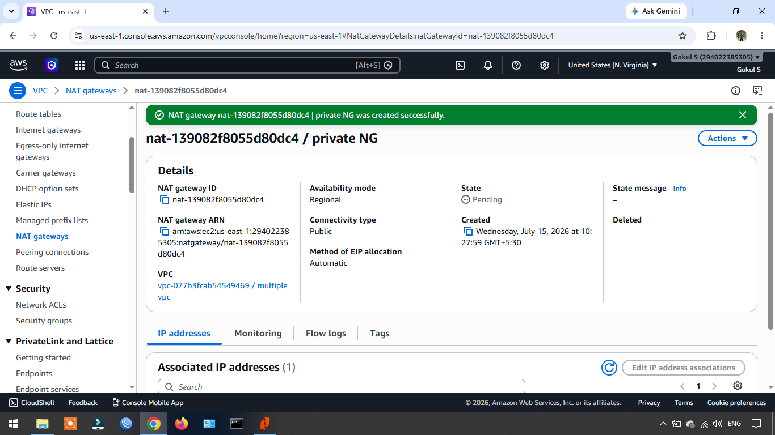

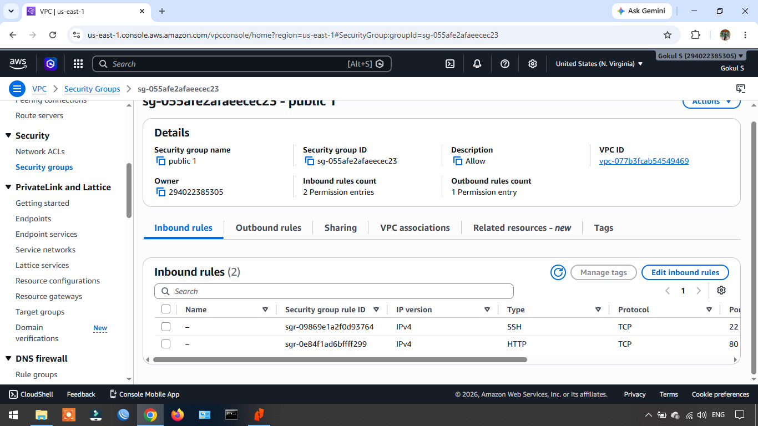

Task2: Create Linux Instance & Install Apache Webserver (EC2) on newly created 2 public subnets:
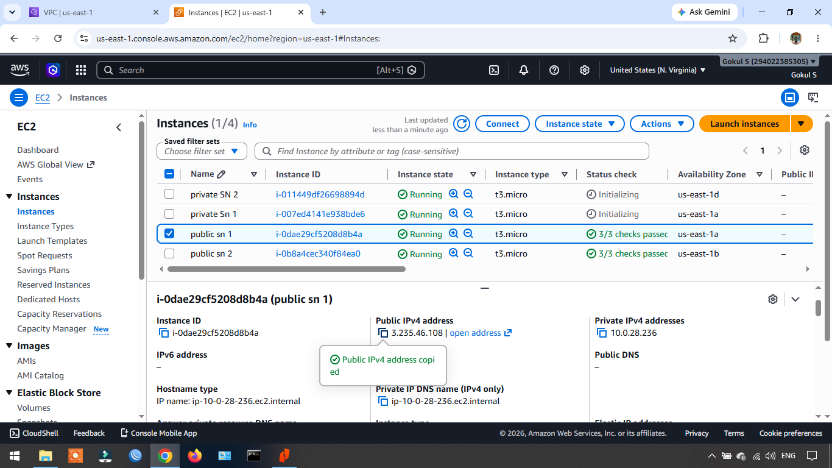

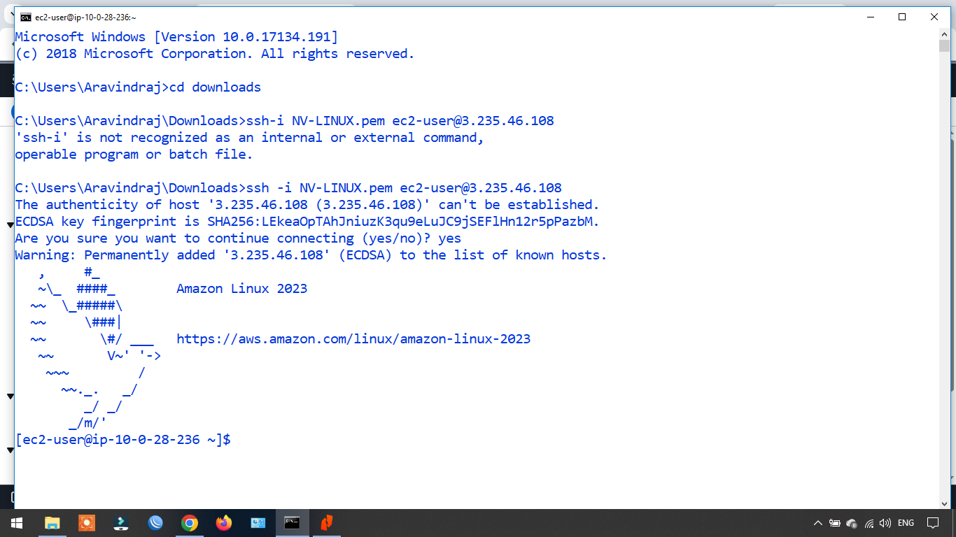

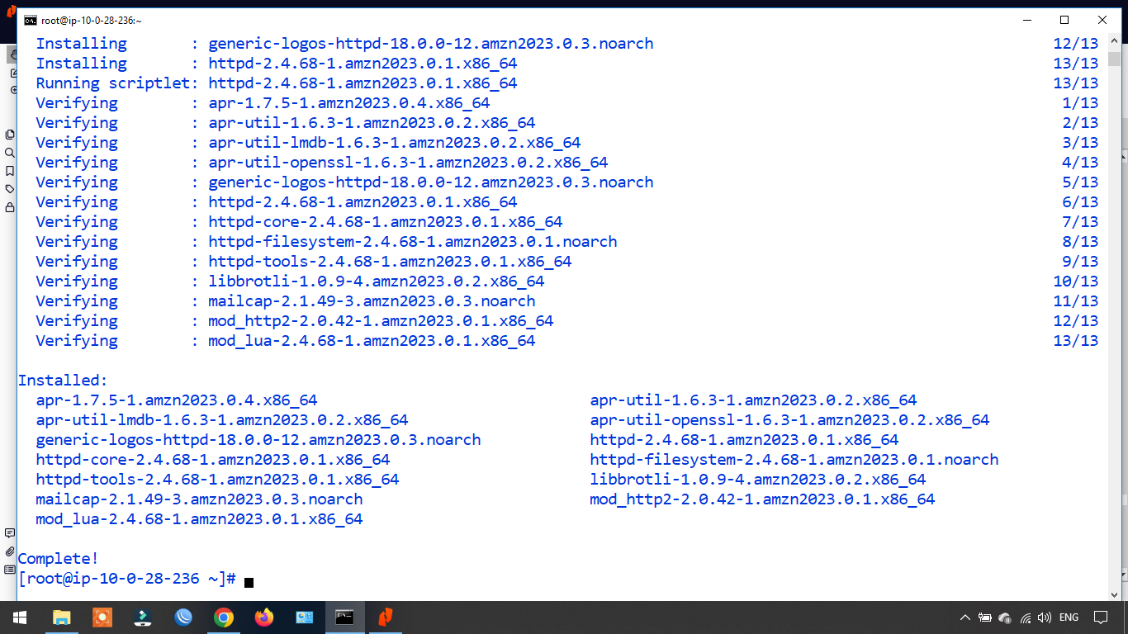

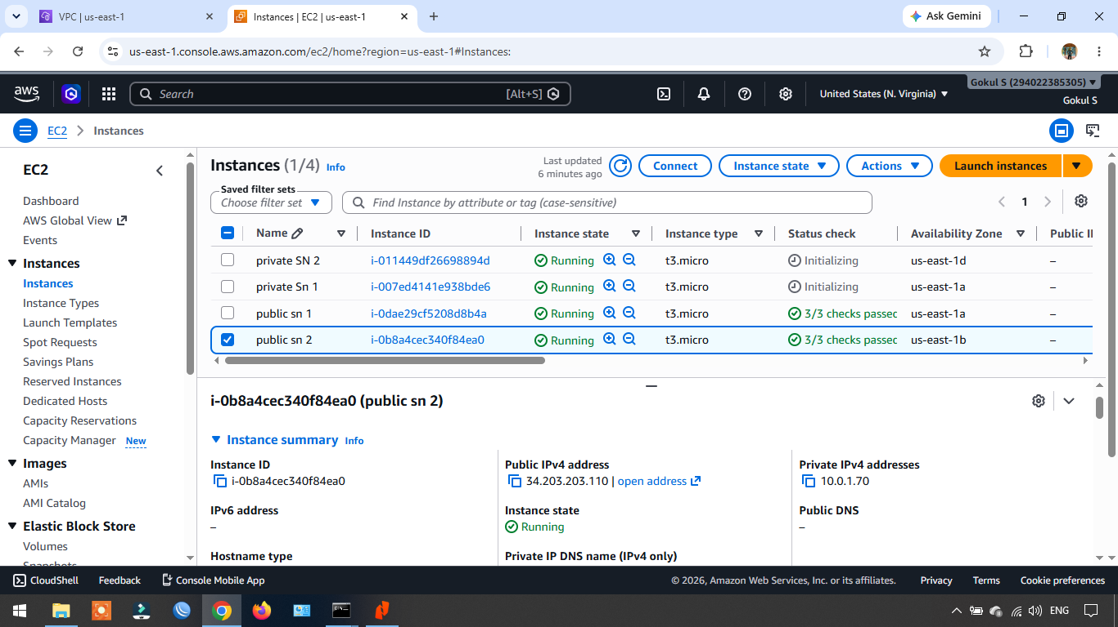

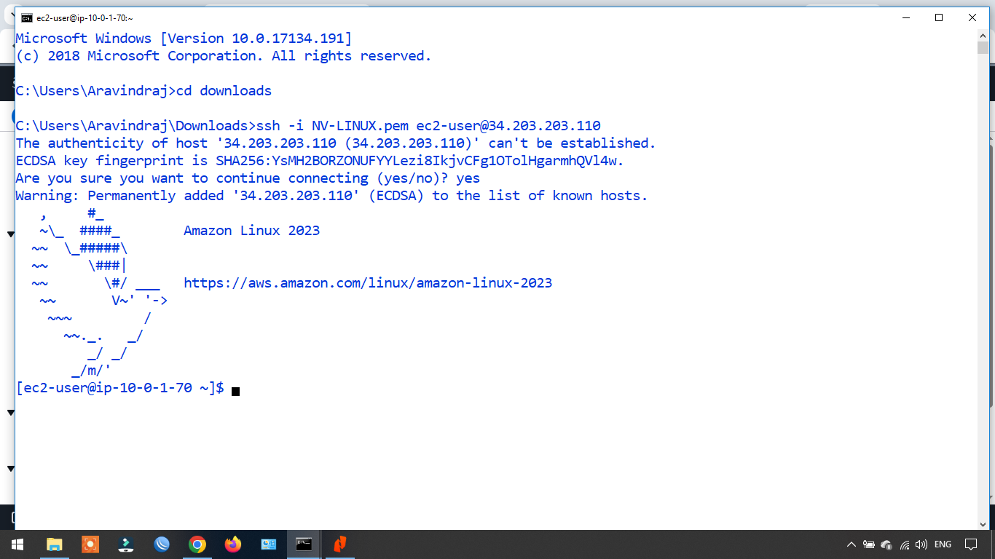

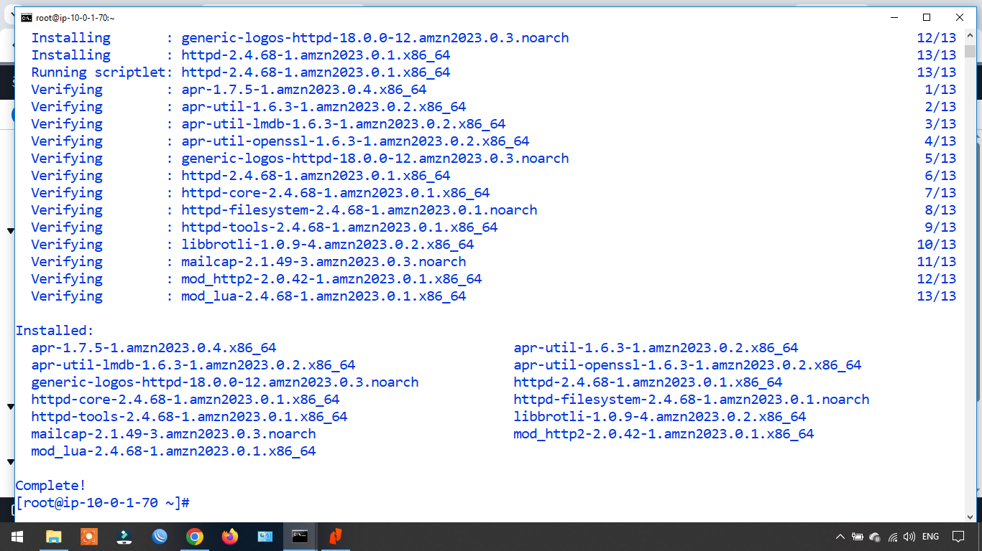

Task3: Create Linux Instance (EC2) on newly created private subnet:

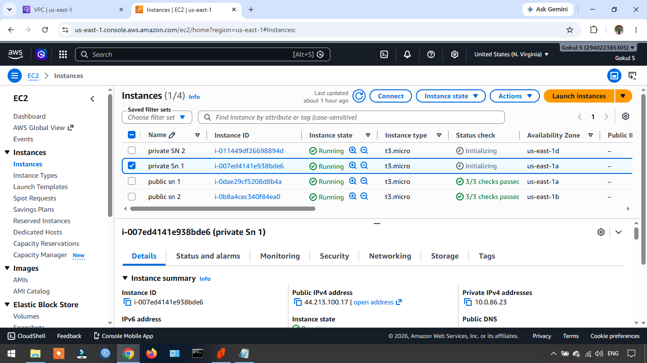

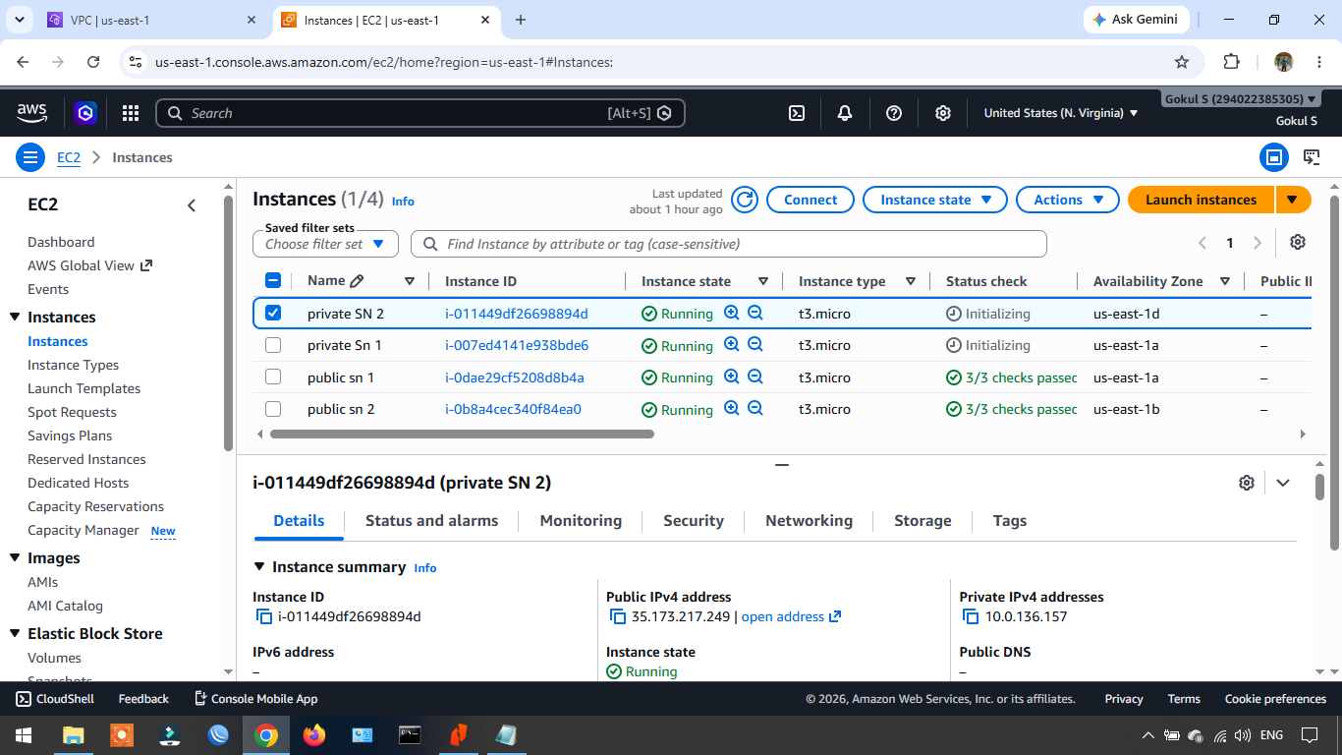

Task4: Configure Public subnets instances should able to communicate with another public subnet instances only. Note (not in private subnet)

Task5: Configure Private subnets instances should able to communicate with another private subnet instances only. Note (not in public subnet)

